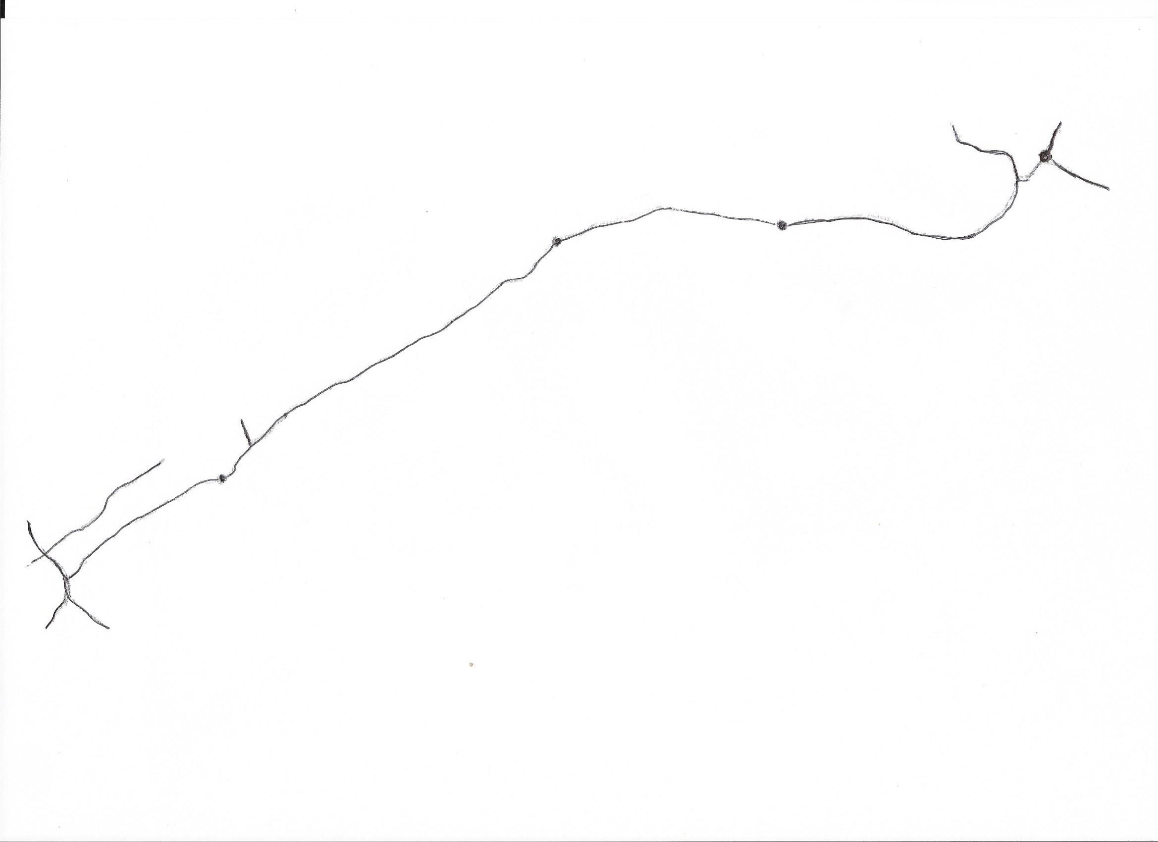

Whitmuirhaugh Farm

TD5 8HP

A 698

Sam Leitch Memorial Autocross

B 6350

From Wooler

B 6350

Sprouston

KELSO

Coldstream

From Berwick

Cornhill

Wark

Carham